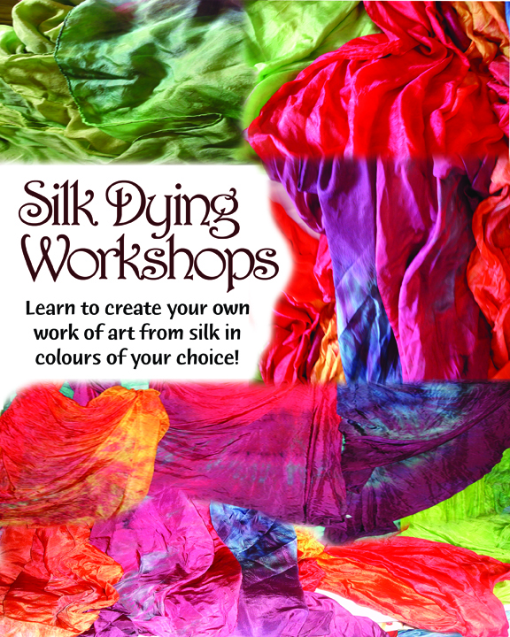
Zahira’s 7th Silk Dying Workshop Registration
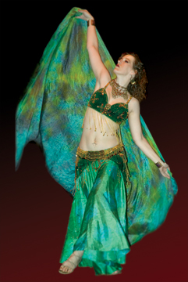
September 15th, 2012 (9월 15일) * 12p.m.아침 - 6 p.m. 오후
*learn techniques as well as variances, between different dyes and material 염색기술을 배웁니다.
* create your own stunning 1-3 yard silk work of art,당신만의 창의적인 3m 실크 미술을 만들어봅시다.
* choose from a variety of colors to work with. 많은 색상을 선택하실 수 있습니다.
* learn about creating patterns and layers, * habotai silk (5-8 m/m), dyes & instructions provided
실크, 염색과 지시사항이 제공됩니다.
Regular Commitment Deposit required예치금이 요구됩니다.
by August 30th for workshop on September 15th (Registration after August 30th add 5,000원)
Silk Dying Workshop fees:
1 veil - $32.00 (73,000원) Deposit $30.00 (36,000 원) ____
(It includes all materials needed to make a 3 meter silk veil).
Add additional silks per person and save!
2 veils - $80.00 (93,000 Won) Deposit $40.00 (47,000 Won) ____
3 veils - $97.00 (113,000 Won) Deposit $50.00 (58,000 Won)____
$16.00/veil (18,000 won) extra for heavier weight silk ____
If you are unable to attend but you would still like to order a silk made by Zahira SJ contact her at zsjsilks@k3worksstudio.com for details. Prices are the same.
Payment options: CASH ________ CREDITCARD (online)________ PAYPAL ______ T/T_______
Name:___________________________________ Phone #: _______________________________________
Address:____________________________________________________________________________
Dance Instructor/ teacher/ school: _____________________ Email: __________________________________
Attending the evening Hafla: NO___ YES! ____ performing: NO___ YES! ______
Hafla RESERVATIONS are REQUIRED! zsjsilks@k3worksstudio.com
***Note: Silk dying classes are one where you have a 98% chance of getting dye on your clothes, so please dress accordingly. Plan to get messy!
*** (cheap clothes that you don’t mind the colours changing and some cheap sandals or flip-flops so your feet don’t end up pretty colours too!)
• Part of this class takes place outside. (sheltered area in case of rain)
• Minimum age is 10 years (12 in Korean age). All minors must be accompanied by their parent.
(2 veil registration required: 2 veils - $78.00 (90,000 Won) Deposit $40.00 (45,000 Won))
• • A minimum number of students required. Must have 6 registrants per Workshop by August 4th
• • Instruction is mainly in English (limited Korean and German translation available)
• • Students will be provided with all basic materials and an instruction booklet (in English). All materials are provided for in the workshop fee.
• • The workshops will be limited to 12 students, so RSVP as soon as possible.• • The balance of fees will be collected at the beginning of the class or can be paid online.
• • • Dyes used• • • • • • • • • • • • • • • • • •
***This workshop uses professional Fiber Reactive Procion Dyes. Not the ones you can buy on the cheap at the supermarket. All colors are brilliant, mouth-watering, and permanent. They don't fade, even after repeated washings. They are safe and easy to use. Superior to supermarket dyes in every way!
USED FOR: Tie-Dye, Tub Dyeing, Low Immersion Dyeing, Batik, Dye Painting, Silk Painting, Screen & Block Printing or Stenciling, even Tie-dyeing Silk in a Microwave
USED ON: All natural Fibers (Cotton, Rayon, Hemp, Silk, etc.), Wood, Cane, and Rattan
• • • • • •
You may have seen other silk dying workshops for less that took less time, but please remember, in most of these, participants dyed small scarf-sized pieces with an additional emphasis of using them in our homes as table cloths or wrapped around pillow forms. Not 3 meter lengths (or more) of silk that uses much more time, material, dye and fixative.
• • • • • •
* Zahira SuJong, Kristina Kauss ,K3cafe, K3 Works Studio and the premises (location)
are Not Responsible for personal color choices.
* Zahira SuJong, Kristina Kauss, K3 Works Studio and the premises (location) or associates thereof, are not responsible for any accidents, injuries or loss in regards to myself or any guest of mine while attending/participating in the workshop or while travelling to or from the event
Signature: ____________________________________________ Date: ______________________________
Please email this form to zsjsilks@k3worksstudio.com and then print out and bring this form with you.

